VAV Simple Simulation

A VAV (Variable Air Volume) box is a common commercial mechanical device for space comfort control. There are several different configurations, but a common version modulates a cool air flow (54-68 degrees) coming from an AHU (Air Handler Unit) and a reheat valve to temper the air when needed to control space temperature using a PID control loop Consider a building with a 25000 square foot floor footprint. There may be 10-20 VAV controllers to control temperature in the different areas which based on the space utilization. Each VAV is balanced to provide minimum and maximum air flows based on the mechanical engineer’s calculations of heating and cooling loads for different spaces in the building. A mechanical engineer will size the minimum and maximum air flow each VAV will be calibrated to supply to the space it serves. A pressure independent system will include an airflow sensor so the VAV controller can scale its damper position from a low limit position to 100% between its configured minimum and maximum flow settings. VAV boxes come in different sizes to handle are range of air flow according to the space volume and load requirements.

The following screen clips highlight the list of key variables one might present a building Engineer. . The UI experience must support range validation. For example, the nviSetptOffset should be limited to +/- 5 deg F. If we provide access to the minimum and maximum air flows, you need to enforce rules such as min flow can not be greater than 50% of the max flow. An additional restriction may prevent going lower than a certain offset. Ranges from 0-1000 CFM should be used in the example.

The point nviApplicMode is used to schedule by the VAV controller (HVAC_AUTO (0) | HVAC_COOL (3) | HVAV_OFF). The point nviOccSensor could be driven by the output of the BACnet Thermostat.

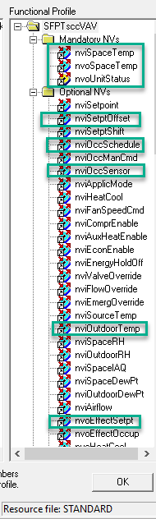 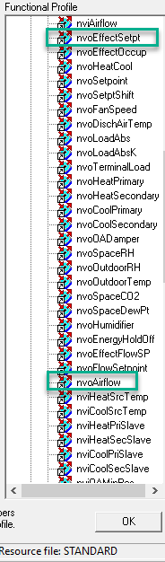 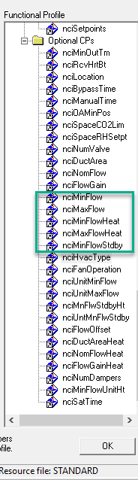

Most VAVs controller have a built-in temperature sensor and also support an input variable that when set to a valid temperate by a peer device, will be considered the temperature used for the PID control algorithm of the VAV controller. In this simulation the temperature sensor of the EVB 6050 is not used. Control depends on a valid temperature input. The setpoint is defined by a CP that is type SNVT_temp_setpt as shown here

. 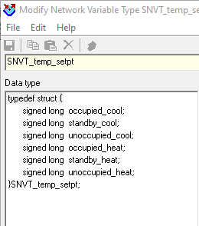

Common values are 76, 81, 85, 69, 65, 60 in order of the fields shown in the above screen clip. The Heating or Cooling state may be determined by the AHU or based on Outdoor. Consider a VAV controller that monitors the OAT sensor through nviOutdoorTemp to determine if it is operating in heating or cooling mode temperature (Not part of the simulation at release 1.0.1). **In this Simulation, the VAV is only operated in cooling mode.**

The variable nvoUnitStatus look like this with the points of interest for display that should be in the web visualization:

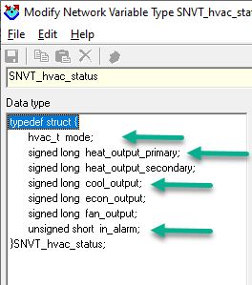

The mode field is an Enum, that will report the values highlighted in this screen clip. It is important to note that some enumerations are equipment specific. The type hvac_t is applied in central plant and terminal equipment applications. For example, a VAV unit will never report HVAC_ICE but a chiller plant controller certainly would.

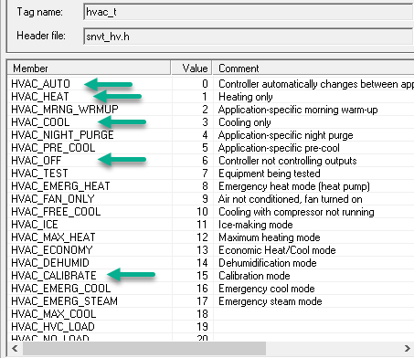

# VAV Simulation

At startup, the VAV controller will go execute the damper endpoint calibration. This normally take about 90-180s. In the simulation this takes about 20s. During this time the nvoUnitStatus.cool_output will swing from 0% to 100% while the mode is HVAC_calibrate.

After the startup sequence, the VAV will go to HVAC_OFF, until the nviApplicMode is scheduled to HVAC_AUTO or HVAC_COOL. This should be at a 60s Heartbeat, so the unit will march to the system orders shortly after the calibrate sequence completes.

The VAV simulation will modulate the cooling % based error between the nvoEffectSetpt and the nviSpaceTemp. If the temperature is within 1 degree C, the cooling% will hold steady. The simulation does not attempt to module a space temperature. In an actual system, the air flow delivered to the space would change the temperature and as the error between the effective setpoint and the temperature approaches 0, the cool_output command would stop changing. You can use the nviSetptOffeset to close the error.

The left button on the EVB 6050 will be use to simulate a fault condition with will cause the nvoUnitStatus.in_alarm to step between 0 – No error, 1 – Temp sensor fault, 2 – air flow sensor fault, 3 – damper fault. The nvoUnitStatus.in_alarm will report this value. If you have an nciRcvHrtBt defined (60s minum) After the receive timeout on nviSpaceTemp, the temperature will go to the Invalid value.

The nvoEffectSetpt will follow the nviOccSensor command and the nviApplicMode. When VAV nviApplicMode is set to HVAC_OFF, the nvoEffectOccup is OC_UNOCCUPIED, the system is unoccupied regardless of the nviOccSensor value.

When the VAV box is operating in HVAV_COOL, and the nvoEffectOccup is OC_OCCUPIED, the nvoEffectSetPt will include the nviSetptOffset applied to the nciSetpoints.occupied_cool set point.

The simulation Only models cooling mode.

## Integration Notes

The airflow values (nvoAirFlow, SCPTminFlowStby, SCPTminFlow, SCPTmaxFlow) are in liters/s. In this application, US units should be Cubic Feet/min. (0.472 conversion factor)

nviSetPtOffset – needs a differential conversion (1.8 with no offset supplied)

nviSpaceTemp and nvoSpaceTemp – If nviSpaceTemp is invalid (raw 0x7FFF, 327.67 scaled) The VAV controller will consider this a fault and will not operate the control function. If you turn set SCPTmaxRcvTime to a non-zero value, the application will enforce a 60s minimum. After the rcvTimer expires, the application will set nviSpaceTemp and nvoSpaceTemp to the invalid value.

nviOccSensor will drive nvoEffectOccup. If the nviApplicMode is HVAC_COOL, nvoEffectOccup will reflect OC_OCCUPANCY directly, and OC_UNOCCUPIED as OC_STANDBY. When nviAppLicMode is HVAV_OFF, nvoEffectOccup will go to OC_NUL.

The EVB 6050 LCD provides the user with information about the state of the VAV controller simulation. This picture is what to expect after power up. At this point, which no valid nviSpaceTemp, all attempts to change the nviApplicMode will result in no change to the display.

There are two device level variables:

1. nvoVersion - Reports the Major, minor, and build versions of this application.
2. nviDispF - When set to 1 will the application will use degrees F scaling for the temperature and effective setpoint on the LCD display.